QUICK REFERENCE LEARNING POINTS FROM HARROW SAFEUGARDING PARTNERSHIP
LEARNED LESSONS REVIEW: BABY ‘K’

Learning about Physical Harm to Babies and Young Children – Assessing Risk
Background
A first-time mother experienced low mood following the birth of her baby which affected her ability to manage when the baby would not settle or stop crying. She sought help and disclosed to a therapist that she had on occasions shaken and hit her baby.
The therapist sought advice from a Safeguarding Advisor and referral was made to MASH. MASH responded to the referral as a Child in Need and not as a child in need of Protection. The MASH health representative was not consulted in the decision-making.
Health colleagues challenged this decision as they considered the baby was at risk of significant harm and in need of immediate medical examination. They escalated their concerns when their initial challenges did not bring about the expected response.
A Strategy Meeting was then held, and it was agreed that a medical should be arranged. The case was managed as a single agency s47 enquiry.
The medical confirmed that the baby had not been injured and the case was immediately stepped down to a Child in Need for assessment.
The review was instigated in response to the lack of necessary and immediate action taken by the MASH in protecting the baby.

Assessing Risk
The existence or degree of injury
Practitioners downgraded the perceived level of risk based on the fact that no injuries had been sustained by the baby. Insufficient focus was placed on assessing the potential and ongoing risk of shaking and hitting a baby. Learning: Practitioners must avoid being influenced by ‘unconscious’ interpretations of ‘luck’ when assessing current and future risks.
Disclosure and compliance
The mother readily disclosed that she was struggling as a parent and that she had shaken and hit her baby. She clearly indicated a willingness to receive help, but until the impact of that help could be assessed, this was not a reliable indication that her baby was at lower risk.
Learning: Practitioners should be mindful of the ‘Rule of Optimism’ when assessing risk.

Recognising & Responding to Physical Harm to Babies & Young Children
Despite the considerable research available, the review identified a lack of understanding amongst some practitioners of the serious harm that can be caused to babies and young children through shaking and slapping, including the risk of serious brain injury.
Learning: Practitioners should access relevant training on physical injury to babies and young children. Further information can also be obtained from https://assets.publishing.service.gov.uk/government/uploads/system/uploads/attachment_data/file/1017227/National_Review_of_Non-Accidental_Injury_in_under_1s.pdf

Risks that are Transferrable to the Workplace
The mother was known to work for the NHS, but no consideration was given to whether the risks she presented to her child were also risks that she might present in her place of work when she was able to return there.

Learning: consultation should always take place with the LADO covering the area of employment to help assess any risk to other children or vulnerable groups.

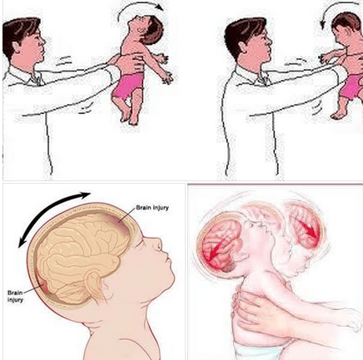
Confidence in challenging other professionals
Good practice: The lack of understanding by MASH professionals about the impact of shaking babies was appropriately challenged by health visitors. When their initial challenges were not adequately addressed, health visitors persisted by escalating their concerns through Safeguarding Advisors and Designated Leads until appropriate action was taken by senior management intervention.
The review identified that the initial decision making in the MASH was a unilateral one, without any consultation with health or police representatives. Learning: MASH must take advantage of the specialist knowledge available from key agency representatives to inform initial ratings of risk, especially in relation to physical abuse.

Impact of Covid-19 - Isolation
The mother had no direct support from family members due to the lockdown and her husband worked long hours too. Consequently, as a first-time mother she was particularly isolated during this period.
Initial contact and assessments by health professionals were undertaken by telephone, so the potential for identifying concerns at an earlier stage were limited. Learning: The Partnership will include specific reference to the impact of Covid-19 and other national crises in the Assessment Framework.

