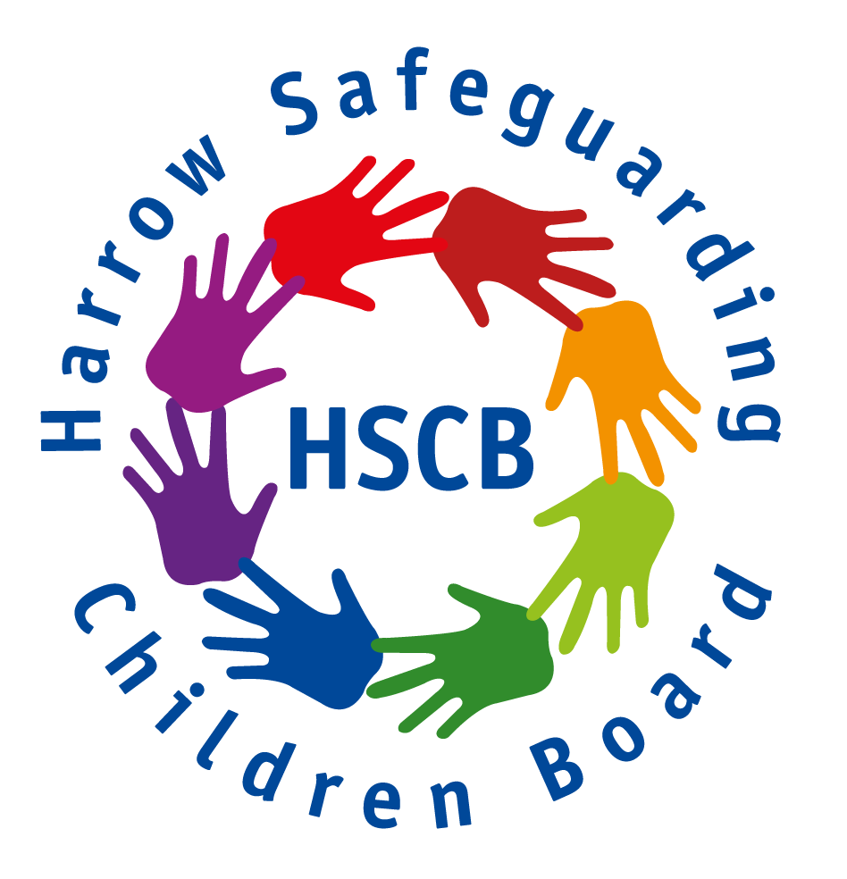

HARROW SAFEGUARDING CHILDREN BOARD
Terms of Reference – revised May 2019

- Legal context

The Children and Social Work Act 2017 introduced a requirement for new Safeguarding Partnership Arrangements to be established in every local authority. These partnerships replace Local Safeguarding Children Boards.

In Harrow, the new arrangement is led by Harrow Strategic Safeguarding Partnership and its remit extends to overseeing the safeguarding arrangements for both children and adults with care and support needs.

To maintain a balanced focus, both the Harrow Safeguarding Adults Board (HSAB) and Harrow Safeguarding Children Board (HSCB) will continue with their existing functions to coordinate local arrangements to safeguard and promote the welfare of relevant groups across Harrow and to ensure their effectiveness.

2. Key Concepts for HSCB

Child protection is about the protection of individual children who are suffering
or who are likely to suffer significant harm.

Safeguarding is about preventing harm to children.

- Governance arrangements for the HSCB

The HSCB will have a two-way relationship involving consultation and challenge with the HSSP, but ultimate statutory responsibility rests with the three key partners that make up the HSSP; namely, the Local Authority, CCG and Metropolitan Police Service. The HSCB will keep the HSSP apprised of all relevant developments.

- Membership of the HSCB

It is recognised that safeguarding is everybody’s responsibility and the effectiveness of local arrangements depends on a wide range of agencies and services working collaboratively to a share set of priorities. The following membership of the HSCB aims to reflect this objective:
- Local Authority
- CCG
- MPS
- Schools & colleges (primary, secondary, independent and special)
- Early Years
- NHS Trusts (CNWL, NWLUHT, CLCH
- Royal National Orthopaedic Hospital
- GPs
- NHS England
- Probation
- CRC
- Cafcass
- YOT
- British Transport Police
- London Fire Brigade
- Westminster Drugs Project
- Compass
- Charities (WISH)

- Chairing
The HSCB will be chaired by an independent consultant

- Regularity of meetings
The HSCB will meet three times a year and in response to exceptional circumstances when required.

- Functions of the HSCB

- To collaborate with Harrow Safeguarding Adults Board Board on areas of shared relevance to promote Harrow’s Think Whole Family Approach to Safeguarding

- To ensure policies and procedures (Pan London and local) are available and understood for safeguarding and promoting the welfare of children and young people in Harrow –
- what to do if concerned about a child
- safer recruitment
- allegations management
- information sharing

- To provide a relevant and effective multi-agency training programme

- To monitor and evaluate the effectiveness of what is done by the local
authority and Board partners individually and collectively to safeguard and
promote the welfare of children and advise them on ways to improve.

- To assess the effectiveness of individual agency’s Section 11 arrangements

- To assess the effectiveness of the help being provided to children and families, including early help; and specific areas of need e.g. private fostering or areas of concern such as child sexual exploitation, gang involvement, missing children, FGM, Forced Marriage and Modern Day Slavery

- To Identify and carry out safeguarding practice reviews into cases which raise issues of importance to the area and meet the criteria laid out in Chapter 4 Working Together 2018

- To ensure effective Rapid Review arrangements are in place

- To contribute to any local review that is led by the National Safeguarding Practice Review Panel

- To ensure that learning from both national and local Safeguarding Practice and Rapid reviews inform the development of local practice

- To cooperate with other authorities and their Board partners to safeguard and promote children and young people who lives are affected by relationships and activities that cross geographical borders

- To participate in the local planning of services for children and young people in Harrow

Section 11 of the Children Act 2004. Places duties on a range of organisations, agencies and individuals to ensure their functions, and any services that they contract out to others, are discharged having regard to the need to safeguard and promote the welfare of children.

