SafeLives Risk Identification Checklist for the identification of high risk cases of domestic abuse, stalking and ‘honour’-based violence (DASH)
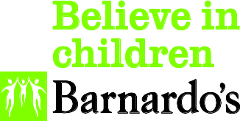

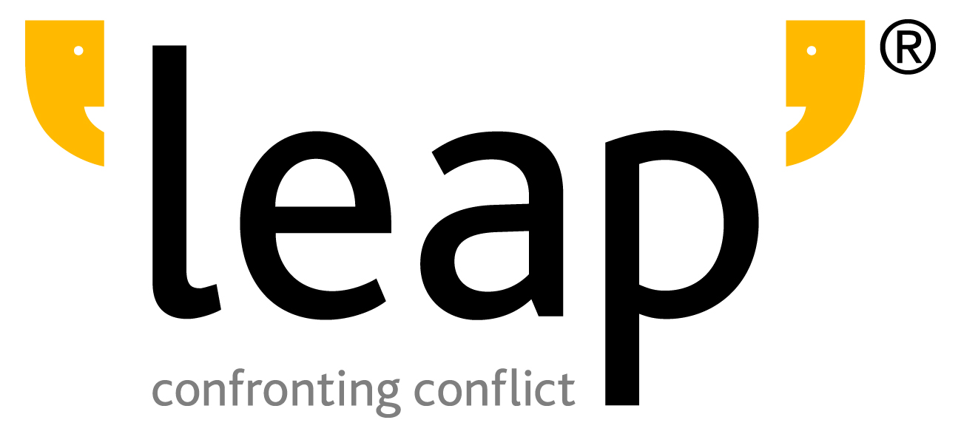
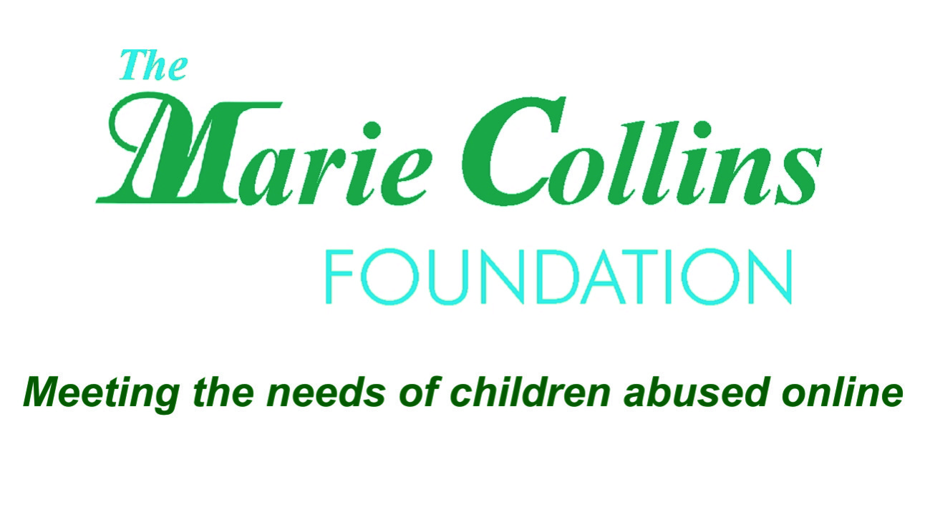
Young People’s Version
Contents
Introduction 3
The aim of the Checklist and guidance 3
Using the Young People’s Checklist 4
Before you begin 4
Using the Checklist 4
Notes on the use of language 6
SafeLives Risk Identification Checklist (RIC) – Young People’s Version 7
The aims of the Checklist 7
Recommended referral criteria to MARAC 7
What the Checklist is not 8

This document is based on the original SafeLives Risk Identification Checklist, which was developed in partnership with Laura Richards, Consultant Violence Adviser to ACPO, and piloted with Advance, Blackburn with Darwen Women’s Aid, Berkshire East Family Safety Unit and the Blackpool MARAC, with expert input from Cafcass, Respect, Jan Pickles, Dr Amanda Robinson, James Rowlands and Jasvinder Sanghera.

We are grateful to the young people who helped us to develop this version of the tool and to Barnardo’s, IKWRO and Leap: Confronting Conflict for convening the young people’s advisory panels.

Introduction
The SafeLives Risk Identification Checklist (RIC) for the identification of risk in cases of domestic abuse, stalking and ‘honour’-based violence in young people’s relationships has been amended from the original version, designed for use with adults in 2009. This Young People’s Checklist will allow you to apply the wide ranging research available on risk in adult cases of domestic abuse, combined with the more limited evidence base that relates to young people experiencing intimate partner abuse, and use it to begin the risk assessment process with a young person who is being harmed within a relationship.

This Checklist forms part of the Young People’s Programme and will be piloted during 2013 and 2014 alongside the collection of data through the work of Young People’s Violence Advisors (YPVAs) and other practitioners trained to work with young people and/or domestic abuse. The form will be reviewed from April 2014.

The aim of the Checklist and guidance

This Young People’s Checklist will help you to identify known risks in domestic abuse and include specific considerations in relation to young people to inform your professional judgment. It will help you to identify suitable cases to be reviewed at a MARAC and inform referrals to children’s social care.

For a version of the Young People’s Checklist with the accompanying guidance, please visit: http://www.safelives.org.uk/Young_People/YP_RIC.htm

Using the Young People’s Checklist
Before you begin

Introducing the Checklist to your client
- Take time to familiarise yourself with the Young People’s Checklist before beginning work with your first client. This will help to ensure you feel confident about the relevance and implications of each question.
- Whilst it is vital to work through the Young People’s Checklist quickly in order to gain an understanding of the client’s situation, it is also important that a relationship with clear boundaries is created first where safety and trust is informed by active listening. The young people consulted during the development of the Checklist were clear that they would respond best to the questions if they had an existing relationship with the person who was asking them.
- Explore the young person’s understanding of what abuse is, helping them to define what the word means to them and identify how it relates to their own experience.
- Introduce the concept of risk to your client. Explain why you are asking these questions, what you will do with the answers, how it will help you as a professional and how it will help the young person. You must also be clear as to who else might see this information.
- Avoid using jargon; opt for plain, simple language.

Confidentiality and safeguarding
- It is important to explain your confidentiality and information sharing policies before beginning to ask the questions. You should be clear that, in most cases, the experience of relationship abuse by a young person will be a safeguarding issue and require a referral to the safeguarding children team. This will create transparency and clarity for the young person about how and when the information they disclose might be used and shared.
- Wherever possible, you should ask the young person to sign a form confirming that they understand and consent to these policies. Alternatively explain that, if they agree, you will sign on their behalf confirming they have understood and consented to the policy over the telephone.

Safety considerations
- Establish with the young person how much time they have to talk to you and whether it is safe for them to do so.
- Obtain the safe contact details of the young person in case the call is terminated, or they have to leave in an emergency.
- If you are completing the Young People’s Checklist on the phone or at the young person’s home, check whether the person who hurts them is around, due back or expected back at a certain time.
- Be aware that a lesbian, gay, bisexual or transgender (LGBT) person accessing services will have to disclose both domestic abuse and their sexual orientation or gender identity. Creating a safe and accessible environment where a young person who has been harmed feels they make such a disclosure, and using gender neutral terms such as partner/ex-partner, is essential.
Using the Checklist
- Ask all of the questions on the Checklist.
- Ensure you have an awareness of the safety planning measures you can offer and put into place. It is also important to be familiar with local and national resources to refer your client to, including specialist services.
- Please note that the ‘don’t know’ option is included where the young person who has been harmed does not know the answer to a specific question. It should be used when ticking ‘no’ would give a misleadingly low risk level. This will also highlight to your agency, the child safeguarding team and the MARAC any areas which require more information to be gathered.
- Use the referral/care pathway to inform your practice. You may also find it helpful to familiarise yourself with SafeLives’ practice briefing for IDVAs on working with young people experiencing relationship abuse.

When to use the Checklist
You should use the Young People’s Checklist with every young person who discloses to you that they are experiencing current abuse. The Checklist offers an opportunity to identify the levels of risk a client may be exposed to, and to offer appropriate services.

‘Current’ abuse is where there has been any form of relationship abuse (including psychological, financial, sexual and physical abuse) occurring within the last three months. However this is not an absolute: risk can change and each young person’s situation will differ. Therefore it is essential that professionals consider each case based on its own circumstances.

For this reason, in practice, the Young People’s Checklist will not easily apply to historic domestic abuse cases, ie if the abuse has ceased and the client is in need of general support not crisis services (NB current/recent abuse covers the spectrum of emotional/physical/financial/sexual and psychological abuse). However, if the client has only recently split from their partner, or recently rekindled a relationship that was abusive, the Checklist will still be relevant.

You should aim to complete the Young People’s Checklist on your first contact with the client. However, as has been highlighted, it may be best to first ensure an appropriate relationship is established between yourself and the young person to enable them to confide in you more readily. In such cases, be sure to complete the form at the earliest appropriate opportunity.

The Young People’s Checklist includes questions about static and dynamic risk factors.

- Static risk factors are those that will not change. For example, ‘Has […] ever threatened to kill you or someone else?’
- Other questions explore dynamic risk factors, such as pregnancy, financial issues or sexual abuse. Where the questions on the Young People’s Checklist refer to ‘current’ (eg ‘Has the current incident resulted in injury?’) you should refer to the above definition to establish whether an incident ought to be included.

Who should the Checklist be used with?
Normally the Checklist will be completed with a young person who is experiencing relationship abuse, including stalking and ‘honour’-based violence. However, you may receive additional information from other professionals such as the police. If you do, please note this on the form.

Information should not be gathered from other family members unless a young person specifically asks you to do this. Consider that, in certain situations such as ‘honour’-based violence, family members may also pose a threat.

The safeguarding duty
All professionals have a responsibility and safeguarding duty to respond to young people at the earliest point possible to prevent exposure to domestic abuse and escalation. A risk threshold should not form the basis for a safeguarding referral; this should be based on child protection guidelines and law. The risk assessment will inform a professional’s understanding of risk but not provide a threshold for safeguarding.

Relationship abuse towards young people who are under the age of 18 is likely to be a safeguarding issue. Use the Young People’s Checklist to document your decisions and the actions taken in relation to safeguarding referrals and be aware that:

- Where the client is aged 13-15, the experience of relationship abuse is a safeguarding issue and the safeguarding authorities should be made aware of the case. No guarantee of confidentiality can be made to the young person.
- Where the client is aged 16-18, again the experience of relationship abuse is a safeguarding issue and appropriate referral routes must be followed. However, the MARAC should form part of those routes and should be aligned to the safeguarding process.

The evidence and its limitations: professional judgement
As has been outlined, the evidence used for the original, adult version of the Checklist was based on the experience of adult victims of domestic abuse, stalking and ‘honour’-based violence. However, the factors do apply to young people’s experiences of abuse and by asking the questions you will gain a stronger understanding of their situation.

Alongside your professional judgement, use of this form will help you to understand the risk faced by the clients you work with. These indicators can be organised into factors relating to:

- The behaviour and circumstances of the person causing harm.
- The circumstances of the young person who has been harmed.

Generally these risk factors refer to the risk of further assault, although some are also linked to the risk of homicide. We have also highlighted factors linked to ‘honour’-based violence, gang or territory issues and child sexual exploitation which must always be taken extremely seriously. Young people’s experiences can differ from adults and this has also been highlighted accordingly.

Notes on the use of language
Professionals may refer to the people referred to their service as ‘clients’ or ‘service users’. In this document we use the term ‘young person who has been harmed’ to describe the person with whom you are completing the form, and who has been harmed by their partner, ex-partner and/or family member. The term young person and ‘young person who has been harmed’ are used interchangeably depending on the context. Where required for ease of reading the term ‘client’ is also used occasionally.

We have chosen not to use the term perpetrator to describe the person who is causing harm; this is to acknowledge that the person who is causing the harm may also be under eighteen. We are conscious that labelling young people can be unhelpful as it may limit the belief of all parties in the individual’s capacity to change the behaviour. This term is not used to minimise the abusive behaviour or the impact that it will have on those who experience it, neither is it meant to excuse those who cause harm to others from being held to account for their behaviour.

We also acknowledge that the person causing harm may be much older than the young person being harmed, with more embedded patterns of behaviour. We have opted to used consistent language for ease of use; however, on a small number of occasions where adults are referred to and the information is more succinctly and accessible presented, the term perpetrator does remain.

SafeLives Risk Identification Checklist (RIC) – Young People’s Version

The aims of the Checklist
- To help frontline practitioners identify risk in cases of domestic abuse, stalking and ‘honour’-based violence within young people’s relationships.
- To decide which cases should be referred to MARAC and other safeguarding forums; to inform referrals to children’s social care; and to raise issues where other support might be required. A completed Checklist becomes an active record that can be referred to in future for case management.
- To offer a common tool to agencies that are part of the MARAC or other safeguarding processes, and provide a shared understanding of risk in relation to domestic abuse, stalking and ‘honour’-based violence in young people’s relationships.

How to use the Checklist
Before completing the Young People’s Checklist for the first time we recommend that you read the full practice guidance.

Risk is dynamic and can change very quickly. It is good practice to review the Young People’s Checklist after a new incident, every 4 weeks and at the point where the young person exits your service.

Before completing the form for the first time we recommend that you read the full practice guidance and FAQs. These can be downloaded from: http://www.safelives.org.uk/marac/RIC_for_MARAC.html. Risk is dynamic and can change very quickly. It is good practice to review the checklist after a new incident.

Recommended referral criteria to MARAC
You have a responsibility and a safeguarding duty to respond to young people at the earliest point possible to prevent exposure to and escalation of abuse. Thus, the recommended referral criteria to MARAC are as follows:
- Professional judgement
The application of professional judgement by a YPVA or another trained practitioner is particularly important when identifying risk in under 18s, as young people may minimise violence and abuse and may be reluctant to tell adults what is happening in their relationship.
If a professional has serious concerns about the situation of a young person who has been harmed, they should refer the case to their local safeguarding children team and, where appropriate, to the MARAC. There will be occasions where the particular context of a case gives rise to serious concerns, even if the young person who has been harmed has been unable to disclose the information that might highlight their risk more clearly.
This could reflect extreme levels of fear, minimisation, cultural barriers to disclosure, immigration issues or language barriers particularly in cases of ‘honour’-based violence. This judgement would be based on the professional’s experience and/or the young person’s perception of their risk even if they do not meet criteria 2 and/or 3 below.
Professional judgement should never be used to downgrade the level of risk shown by the actuarial score (see ‘Visible high risk’, below).
- ‘Visible high risk’
The number of ‘ticks’ on the Young People’s Checklist. If you have ticked 14 or more ‘yes’ boxes the case would normally meet the MARAC referral criteria for adults and, if the young person you are working with is 16 or over, you should give serious consideration to referring them to MARAC . If the young person is under 16, refer the young person to children services and consider together the most appropriate care pathway.
The actuarial threshold of 14 ticks has always been seen as a safety net to ensure that those cases with many visible risk factors are heard at MARAC. However, in the case of young people, we would expect that many would have additional vulnerabilities (see the last section of the form) which might frequently mean that a lower actuarial score would constitute a high risk case.
The importance of professional judgement remains unchanged whatever the level of actuarial threshold. We have left the 14 ticks as a rational threshold at which a MARAC referral should be made but would expect in practice that you would be exercising your professional judgement about the level of risk and whether a MARAC referral is appropriate.
As yet there is no score that can be used to provide a threshold for ‘high risk’ in young people. The current score used to describe high risk for adults is 10 ticks and so, should a young person receive this score when you complete the Checklist, a high risk response will be required. However, if the young person does not reach this score, do not think that their risk level is necessarily manageable or not high. Pay particular attention to your professional judgement and escalation in all cases. The results from a checklist are not a definitive assessment of risk; they should provide you with a structure to inform your judgement and act as prompts to further questioning, analysis and risk management whether via a MARAC or in another way.
- Potential escalation
Where you are made aware that the young person has been harmed by a person who has hurt them before - either because they tell you about several incidents, or because you are made aware of previous agency interventions and/or police callouts - consider how the situation is escalating. Escalation can happen quickly in young people’s relationships and professionals must be alert to this.
The responsibility for identifying your local referral thresholds rests with your local MARAC and safeguarding authorities. Through the work of the Young People’s Programme and the assistance of our Regional Development Officers, SafeLives can help to develop these thresholds with you.
What the Checklist is not
The Young People’s Checklist will provide valuable information about the risks that associated children are living with. However, it is not a full risk assessment for children who are living in households where domestic abuse is on-going. The presence of children increases the wider risks of domestic abuse, and step-children are particularly at risk. If risk towards children is highlighted, you should consider what referral you need to make to obtain a full assessment of the child/children’s situation.
While the Young People’s Checklist should prompt you to explore whether a young person is at risk of sexual exploitation, it is not a comprehensive child sexual exploitation risk assessment.

SafeLives DASH Risk Identification Checklist for the identification of risks in cases of domestic abuse, ‘honour’- based violence and/or stalking
Young People’s Version

This form is suitable for use with young people aged between 13 and 17.

This Young People’s Checklist is split into questions that require yes/no responses, and areas where you are required to make observations. Please use the comment boxes provided throughout the form to record your professional judgement about how the young person’s specific situation affects their risk.

At the end of the Checklist, consider the number of questions the young person has answered yes to and your professional judgement in combination, and offer risk management options based on this. You have a responsibility and a safeguarding duty to respond to young people at the earliest point possible to prevent exposure to and escalation of abuse. It is assumed that your main source of information is the young person who has been harmed. If this is not the case please indicate in the right hand column.

Your feelings | YES | NO | DON’T KNOW | State source of info if not the victim (eg police officer)
- Are you frightened?  Comment: | ☐ | ☐ | ☐
- What are you afraid of? Is it further violence?  Comment: | ☐ | ☐ | ☐
- Are you feeling low or finding your emotions hard to cope with?  Are you having suicidal thoughts? | ☐ | ☐ | ☐
Consideration as part of your professional judgement
- Does the young person recognise what a dangerous situation might be and their own vulnerability?

- Are they exploring risk-taking behaviour as part of their development? How might this affect their safety?

- Would this young person involve the police if they were to be hurt again?

Comment:

What is happening to you now | YES | NO | DON’T KNOW | State source of info if not the victim (eg police officer)
- Has the current incident resulted in injury?  Please state what and whether this is the first injury: | ☐ | ☐ | ☐
- Does [INSERT NAME OF INDIVIDUAL WHO IS HARMING THE YOUNG PERSON] constantly text, contact, follow, stalk or harass you, either in person, online or by phone? | ☐ | ☐ | ☐
- Does […] try to control everything you do? (For example, who you see, or what you wear?)  Do they get jealous about anything you do? | ☐ | ☐ | ☐
- Is the abuse happening more often? | ☐ | ☐ | ☐
- Is the abuse getting worse? | ☐ | ☐ | ☐
Consideration as part of your professional judgement

- How old is the young person? Where are they within the formal education system?

- Is there any evidence that the young person may be minimising or exaggerating their experience?

Comment:

Your life and relationship | YES | NO | DON’T KNOW | State source of info
- Do you see your family/friends as much as you would like? Does […] stop you from seeing friends and family or professionals?  Comment: | ☐ | ☐ | ☐
- Are you pregnant or do you have a baby? | ☐ | ☐ | ☐
- Are there any financial issues?  For example, is […] experiencing difficulties with money (debts or loans) or are you dependent on […] for money or do they take money from you? | ☐ | ☐ | ☐
Consideration as part of your professional judgement

- Is this the first relationship the young person has been in? How is this impacting on their friendship group/understanding of acceptable behaviour?

- Has the young person experienced abuse and violence within their family and has this affected their understanding of effective conflict resolution or normalised the experience of violence? Does it also limit the safe places they can be?

- Is the young person involved or affiliated to any gangs and does this mean that there are additional risks posed by other people?

- Is the young person at risk of sexual exploitation? Specific risk factors may include being reported missing from care, being missing from home, being in the care of the local authority and living in a residential home. Are you or colleagues aware of specific risks within the community from known perpetrators?

- Does the young person have any specific needs or vulnerabilities in relation to disability and learning difficulties, substance misuse, mental health issues, cultural/language barriers, ‘honour’-based systems or geographic isolation?

Comment:
Things that might have happened to you in the past | YES | NO | DON’T KNOW | State source of info if not the victim (eg police officer)
- Have you broken up with or tried to break up with the person who is hurting you? | ☐ | ☐ | ☐
- If you have children, is there conflict between you and the person who is hurting you over seeing the children? | ☐ | ☐ | ☐
- Has […] ever used weapons or objects (such as a phone or household item) to hurt you? | ☐ | ☐ | ☐
- Has […] ever threatened to kill you or someone else?  If yes, tick who:  You ☐  Children ☐  A member of your family ☐  Other (please specify) ☐ | ☐ | ☐ | ☐
- Has […] ever attempted to strangle/choke/suffocate/drown you? | ☐ | ☐ | ☐
- Does […] do or say things of a sexual nature that make you feel bad or that physically hurt you or someone else?  If someone else, specify who. | ☐ | ☐ | ☐
Things that might have happened to you in the past | YES | NO | DON’T KNOW | State source of info if not the victim (eg police officer)
- Is there any other person who has threatened you or who you are afraid of? | ☐ | ☐ | ☐
- Do you know if […] has hurt anyone else?  If yes, tick who:  Children ☐  Another family member ☐  Someone from a previous relationship ☐  Other (please specify) ☐ | ☐ | ☐ | ☐
- Has […] ever mistreated an animal or their family pet? | ☐ | ☐ | ☐
The person who harms you | YES | NO | DON’T KNOW | State source of info if not the victim (eg police officer)
- Has […] had problems in the past year with drugs (prescription or other), alcohol or mental health, leading to problems in leading a normal life?  If yes, please specify which and give relevant details if known.  Drugs ☐  Alcohol ☐  Mental health ☐ | ☐ | ☐ | ☐
- Has […] ever threatened or attempted suicide? | ☐ | ☐ | ☐
- Has […] ever breached their bail conditions or not followed an order by the police or a judge in court?  Bail conditions ☐  Child contact arrangements ☐  Forced Marriage Protection Order ☐  Other ☐ | ☐ | ☐ | ☐
- Do you know if […] has ever been in trouble with the police or has a criminal history?  If yes, please specify:  Domestic abuse ☐  Sexual violence ☐  Other violence ☐  Other ☐ | ☐ | ☐ | ☐
Consideration as part of your professional judgement
- Is the person who hurts your client older than them? By how many years?

- Is the person who hurts your client gang involved or affiliated? Does this place your client or additional potential victims (consider all family members) at additional risk?

- Comments:

Total ‘yes’ responses

For consideration by professional
What additional concerns do you have, based on your professional judgement/escalation? Comment
Is the young person willing to engage with your service? Describe
Consider the person causing harm’s occupation/interests.
- Could this give them unique access to weapons?
- How involved is your client in relation to any illegal weapons and how might this affect their safety and help seeking?
Describe.
What are the young person’s greatest priorities to address their safety? Describe

The experience of relationship abuse by young people is a safeguarding issue which should be shared with your safeguarding children’s team. A referral will also be required if you believe that there are risks facing any children in the family.
Please confirm if you have made a referral to safeguard the young person and any children they have:  Signed: Date: |  |  | Yes ☐  No ☐
Signed |  |  | Date referral made
If the young person is over 16, do you believe that there are reasonable grounds for referring this case to MARAC? |  |  | Yes ☐  No ☐
If yes, have you made a referral? |  | Yes ☐  No ☐ | Signed
Signed |  |  | Date
Name

This can be downloaded at: http://www.safelives.org.uk/dvservices/Young_people_practice_briefing_for_IDVAs_April_2013_FINAL.p df
For further information about MARAC please refer to the 10 principles of an effective MARAC http://www.safelives.org.uk/marac/10_ Principles_Oct_2011_full.doc
Over the coming months, through YPVA feedback and data collection (from both YPVAs who are case working and through an additional pilot), SafeLives will work to assess whether a similar score describes the experience of young people appropriately, or whether a different threshold/tool is required.
The transitional stage of adolescence can vary between young people, therefore this form may be suitable for use with young people up to the age of 25.

