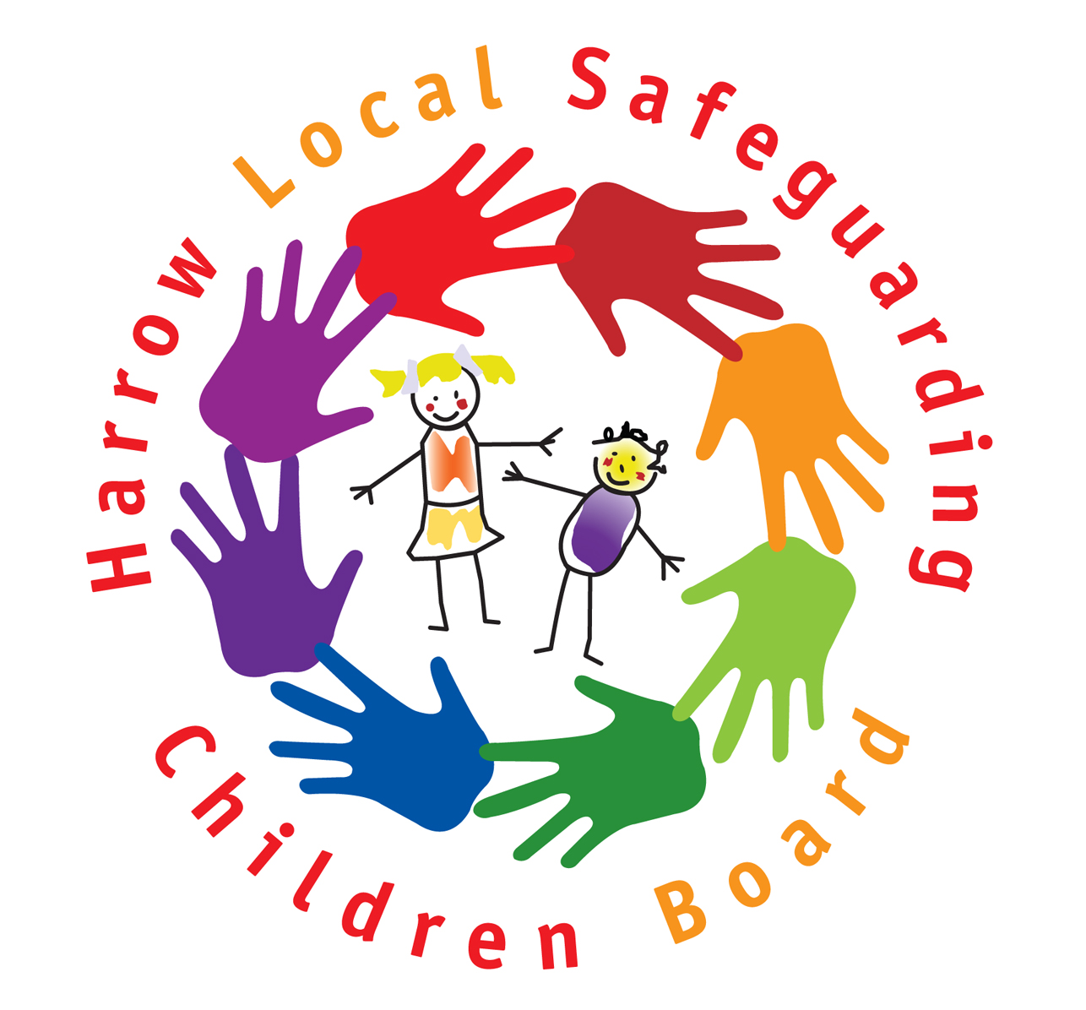

Pre Birth Assessment Tool

The Tool

It is intended that this tool is used to guide the Pre-Birth assessment

Contents
Family Structure Page 2
Information require from Healthcare professionals Page 2
Assessments of the parents & risks to the children Page 3
Overall risk assessments & conclusions Page 10
The Way ahead Page 10

Appendix
Risk assessment Matrix Page 11

Assessment of parents and potential risks to the child

Pregnancy can create special circumstances/influences for both parents, which need to be accommodated and understood by all professionals who come into contact with these families. Pregnancy will have a major impact on most parents’ lives and can affect both behaviour and relationships. Pregnant women’s health and their responses to external factors often change in pregnancy - and the physiological, emotional and social influences that both cause and are affected by these changes can have a direct impact on their behaviour and health and how they manage in key relationships.

1. Family Structure

Names, addresses, ages etc. Extended family and potential support should be included.

2. Information required from midwife / health professional as part of a pre birth risk assessment

This section should be completed with or by an appropriate Health Professional. The central question is whether there is anything in the medical and obstetric history that seems likely to have a significant negative impact on the child? And, if so, what?

2.5 Some basic details:

- Name, age, date of birth, and address of mother.

- Next of kin

- Marital status

- Occupation

2.6 Assessment issues

Are there any aspects of any of the following items that seem likely to have a significant negative impact on the child? If so, what, and how?

- Partner support?

- Family structure and support available (or potentially available or not available)?

- Whether pregnancy planned or unplanned?

- Feelings of mother about being pregnant?

- Feelings of partner / putative father about the pregnancy?

- Dietary intake – and related issues?

- Medicines or drugs – whether or not prescribed – taken before or during pregnancy?

- Alcohol consumption?

- Smoking?

- Previous obstetric history?

- Current health status of other children?

- Miscarriages and terminations?

- Chronic or acute medical conditions or surgical history?

- Psychiatric history – especially depression and self-harming?

3. Assessment of the parents and the potential risk to the child

This section will usually be completed by the Social Worker – but they will need to draw on help from a range of other professionals regarding some aspects of it.

Particular care should be taken when assessing risks to babies whose parents are themselves children i.e, under the age of 18 years. Attention should be given to a) evaluating the quality and quantity of support that will be available within the family (and extended family), b) the needs of the parent(s) and how these will be met, c) the context and circumstances in which the baby was conceived, and d) the wishes and feelings of the child who is to be a parent.

3.1 Relationships

- History of relationships of parents?

- Current status?

- Positives and negatives?

- Violence?

- Who will be main carer for the baby?

- What are the expectations of the parents re each other re parenting?

Is there anything regarding “relationships” that seems likely to have a significant negative impact on the child? If so, what?

3.2 Abilities

- Physical?

- Emotional? (Including self control)

- Intellectual?

- Knowledge and understanding re children and childcare?

- Knowledge and understanding of concerns / this assessment?

Is there anything regarding “abilities” that seems likely to have a significant negative impact on the child? If so, what?

3.3 Social history

- Experience of being parented?

- Experiences as a child? And as an adolescent?

- Education?

- Employment?

Is there anything regarding “social history” that seems likely to have a significant negative impact on the child? If so, what?

3.4 Behaviour

- Violence to partner?

- Violence to others?

- Violence to any child?

- Drug misuse?

- Alcohol misuse?

- Criminal convictions?

- Chaotic (or inappropriate) life style?

Is there anything regarding “behaviour” that seems likely to have a significant negative impact on the child? If so, what?

If drugs or alcohol are a significant issue, more detailed assessment should be sought from professionals with relevant expertise.

3.5 Circumstances

- Unemployment / employment?

- Debt?

- Inadequate housing / homelessness?

- Criminality?

- Court Orders?

- Social isolation?

Is there anything regarding “circumstances” that seems likely to have a significant negative impact on the child? If so, what?

3.6 Home conditions

- Chaotic?

- Health risks / unsanitary / dangerous?

- Over-crowded?

Is there anything regarding “home conditions” that seems likely to have a significant negative impact on the child? If so, what?

3.7 Mental Health

- Mental illness?

- Personality disorder?

- Any other emotional/behavioural issues?

Is there anything regarding “mental health” that seems likely to have a significant negative impact on the child? If so, what?

If mental health is likely to be a significant issue, more detailed assessment should be sought from professionals with relevant expertise.

3.8 Learning Disability

Is there anything regarding “learning disability” that seems likely to have a significant negative impact on the child? If so, what?

If learning disability is likely to be a significant issue, more detailed assessment should be sought from professionals with relevant expertise.

3.9 Communication

- English not spoken or understood?

- Hearing Impaired?

- Visually Impaired?

- Speech impairment?

Is there anything regarding “communication” that seems likely to have a significant negative impact on the child? If so, what?

If communication is likely to be a significant issue, more detailed assessment should be sought from professionals with relevant expertise.

3.10 Support

- From extended family?

- From friends?

- From professionals?

- From other sources?

Is there anything regarding “support” that seems likely to have a significant negative impact on the child? If so, what?

Is support likely to be available over a meaningful time-scale?

Is it likely to enable change?
Will it effectively address any immediate concerns?

3.11 History of being responsible for children

- Convictions re offences against children?

- Previous Child Protection Plan?

- Safeguarding concerns – and previous assessments?

- Court findings?

- Care proceedings? Children removed?

Is there anything regarding “history of being responsible for children” that seems likely to have a significant negative impact on the child? If so, what?

If so also consider the following:

- Category and level of abuse

- Ages and genders of children

- What happened?

- Why did it happen?

- Is responsibility appropriately accepted?

- What do previous risk assessments say? Take a fresh look at these – including assessments re non-abusing parents.

- What is the parent’s understanding of the impact of their behaviour on the child?
- What is different about now?

3.12 History of abuse as a child

- Convictions – especially of members of extended family?

- Subject to Child Protection Plan?

- Safeguarding concerns?

- Court findings?

- Previous assessments?
Is there anything regarding “history of abuse” that seems likely to have a significant negative impact on the child? If so, what?
3.13 Attitude to professional involvement

- Previously – in any context?

- Currently – regarding this assessment?

- Currently – regarding any other professionals?

Is there anything re “attitudes to professional involvement” that seems likely to have a significant negative impact on the child? If so, what?

3.14 Attitudes and beliefs re convictions or findings (or suspicions or allegations)

- Understood and accepted?

- Issues addressed?

- Responsibility accepted?

Is there anything regarding “attitudes and beliefs” that seems likely to have a significant negative impact on the child? If so, what?

It may be appropriate to consult with the Police or other professionals with appropriate expertise.

3.15 Attitudes to child

- In general?

- Re specific issues?

- Expectations of what having a baby means/ how it will alter their lives?

Is there anything regarding “attitudes to child” that seems likely to have a significant negative impact on the child? If so, what?

3.16 Dependency on partner

- Choice between partner and child?

- Role of child in parent’s relationship?

- Level and appropriateness of dependency?

Is there anything regarding “dependency on partner” that seems likely to have a significant negative impact on the child? If so, what?

3.17 Ability to identify and appropriately respond to risks?

Is there anything regarding this that seems likely to have a significant negative impact on the child? If so, what?

3.18 Ability to understand and meet needs of baby

Is there anything regarding this that seems likely to have a significant negative impact on the child? If so, what?

It may be appropriate to consult with Health professionals regarding this section.

3.19 Ability to understand and meet needs throughout childhood

Is there anything regarding this that seems likely to have a significant negative impact on the child? If so, what?

It will usually be appropriate to consult with relevant Health professionals re this section.

3.20 Ability and willingness to address issues identified in this assessment

- Violent behaviour?

- Drug misuse?

- Alcohol misuse?

- Mental health problems?

- Reluctance to work with professionals?

- Poor skills or lack of knowledge?

- Criminality?

- Poor family relationships?

- Issues from childhood?

- Poor personal Care?
- Chaotic lifestyle?

Is there anything regarding “ability and willingness to address issues” that seems likely to have a significant negative impact on the child? If so, what?

It will usually be appropriate to consult with other professionals re this section.

3.21 Any other issues that have potential to adversely affect or benefit the child

e.g. one or more parent aged under 16? Context and circumstances of conception?

3.22 Planning for the future

- Realistic and appropriate?

4. Overall risk assessment and conclusions

The assessment report should address the following issues:

1. Concerns identified

2. Strengths or mitigating factors identified.

3. Is there a risk of significant harm for this baby?

It is crucial to clarify the nature of any risk – of what? From whom? in what circumstances? etc - and to be clear how effective any strengths or mitigating factors are likely to be in reality

4. Will this risk arise?

a) Before the baby is born?

b) At or immediately following the birth?

c) Whilst still a baby (up to 1 year old)?

d) As a toddler? Or pre-school? Or as an older child?

If there is a risk that the child’s needs may not be appropriately met …

5. What changes should ideally be made to optimise well-being of child?

If there is a risk of significant harm to the child:…

6. What changes must be made to ensure safety and an acceptable level of care for child?

7. How motivated are the parents to make changes?

8. How capable are the parents to make changes? And what is the potential for success?

5. The way ahead

Detailed plans must be made on the basis of the above assessment. These plans must include taking, or making every effort to take, all necessary action to protect a baby from any assessed risk of significant harm before, during or immediately after the birth. This should normally be done under Child Protection procedures, and/or by ensuring safety by obtaining a court order.

Appendix Framework for practice: Risk Estimation

This framework was taken from an adaptation by Martin Calder in “Unborn Children: A Framework for Assessment and Intervention” of R. Corner’s “Pre-birth Risk Assessment: Developing a Model of Practice”.

Factor | Elevated Risk | Lowered Risk
The abusing parent | - Negative childhood experiences, inc. abuse in childhood; denial of past abuse  - Violence abuse of others.  - Abuse and/or neglect of previous child  - Parental separation from previous children  - No clear explanation  - No full understanding of abuse situation  - No acceptance of responsibility for the abuse  - Antenatal/post natal neglect  - Age: very young/immature  - Mental disorders or illness  - Learning difficulties  - Non-compliance  Lack of interest or concern for | - Positive childhood  - Recognition and change in previous violent pattern  - Acknowledges seriousness and responsibility without deflection of blame onto others  - Full understanding and clear explanation of the circumstances in which the abuse occurred  - Maturity  - Willingness and demonstrated capacity and ability for change  - Presence of another safe non-abusing parent  - Compliance with professionals  - Abuse of previous child accepted and addressed in treatment (past/present)  Expresses concern and the child interest about the effects of the abuse on the child
Non-abusing parent | - No acceptance of responsibility for the abuse by their partner  - Blaming others or the child | - Accepts the risk posed by their partner and expresses a willingness to protect  - Accepts the seriousness of the risk and the consequences of failing to protect  - Willingness to resolve problems and concerns
Family issues (marital partnership and the wider family) | - Relationship disharmony/instability  - Poor impulse control  - Mental health problems  - Violent or deviant network, involving kin, friends and associates (including drugs, paedophile or criminal networks)  - Lack of support for primary carer /unsupportive of each other  - Not working together.  - No commitment to equality in parenting  - Isolated environment  - Ostracised by the community  - No relative or friends available  - Family violence (e.g. Spouse)  - Frequent relationship breakdown/multiple relationships  - Drug or alcohol abuse | - Supportive spouse/partner  - Supportive of each other  - Stable, or violent  - Protective and supportive extended family  - Optimistic outlook by family and friends  - Equality in relationship  - Commitment to equality in parenting
Expected child | - Special or expected needs  - Perceived as different  - Stressful gender issues | - Easy baby  - Acceptance of difference
Parent-baby relationships | - Unrealistic expectations  - Concerning perception of baby’s needs  - Inability to prioritise baby’s needs above own  - Foetal abuse or neglect, including alcohol or drug abuse  - No ante-natal care  - Concealed pregnancy  - Unwanted pregnancy identified disability (non-acceptance)  - Unattached to foetus  - Gender issues which cause stress  - Differences between parents towards unborn child  - Rigid views of parenting | - Realistic expectations  - Perception of unborn child normal  - Appropriate preparation  - Understanding or awareness of baby’s needs  - Unborn baby’s needs prioritised  - Co-operation with antenatal care  - Sought early medical care  - Appropriate and regular ante-natal care  - Accepted/planned pregnancy  - Attachment to unborn foetus  - Treatment of addiction.  - Acceptance of difference-gender/disability  - Parents agree about parenting
Social | - Poverty  - Inadequate housing  - No support network  - Delinquent area
Future plans | - Unrealistic plans  - No plans  - Exhibit inappropriate parenting plans  - Uncertainty or resistance to change  - No recognition of changes needed in lifestyle  - No recognition of a problem or a need to change  - Refuse to co-operate  - Disinterested and resistant  - Only one parent co-operating | - Realistic plans  - Exhibit appropriate parenting expectations and plans  - Appropriate expectation of change  - Willingness and ability to work in partnership  - Willingness to resolve problems and concerns  - Parents co-operating equally

