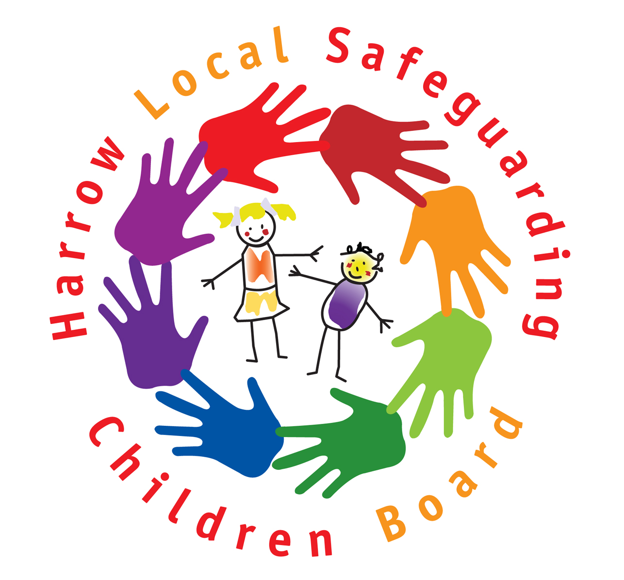

SAFE PRACTICE WHEN WORKING WITH CHILDREN
- Know your organisation’s child protection arrangements  - Know who the designated manager/person is to whom child protection concerns or concerns about staff/volunteers should be reported  - Maintain professional boundaries.  - Do not give out your address, home/mobile phone number or e-mail address unless agreed with senior management & parents  - Do not send children text messages  - Follow guidance about internet/e-mail use  - Do not socialise with children or take them to your home  - Report any concerns that a child has developed a crush on a member of staff  - If a child touches you inappropriately, record and report it to the designated person  - Physical contact should be needs led, age and gender appropriate and culturally sensitive  - Involve another member of staff where contact may be misinterpreted.  - Avoid conduct open to misinterpretation e.g. horseplay, tickling or fun fights.  - Avoid children sitting on your lap  - Where physical contact is necessary to demonstrate the use of an instrument or equipment e.g. PE, games and music tuition, ensure that this is within appropriate boundaries  - Do not do anything personal for a child that they can do for themselves.  - If bathing or changing a child with special needs, try to have another person present  - Follow the agreed care plan for children requiring intimate care on a regular basis  - Supervising children showering or changing should be age and gender appropriate and sensitive to potential embarrassment | - Do not make, or encourage others to make, comments which are sarcastic, demeaning or insensitive, or humiliating, or might be interpreted as such  - Avoid meeting children in secluded areas  - Ensure visual access and/or open door in 1 to 1 situations  - Avoid ‘engaged’ signs  - Avoid being alone with a child in transport  - Only use photography etc as appropriate to an authorised activity  - Ensure a senior member of staff is aware  - Avoid one to one sessions  - Be clear about use/disposal of images  - Be sensitive to children who appear uncomfortable being photographed  - Recognise potential for misinterpretation  - Ensure all images are available for scrutiny  - Do not take, display, or distribute images without consent  - Gifts to individual children should be part of an agreed reward system  - Other gifts should be of insignificant value and given equally  - Do not single a child out for special treatment  - Do not accept gifts regularly or ones of significant value  - Declare any gifts which may be misconstrued  - Follow Health and Safety rules.  - Record and report incidents involving a child, including injuries, according to the relevant procedures e.g. Child Protection, Physical Intervention, Health and Safety  - Report any concerns about a colleague’s behaviour and/or attitude toward a child(ren)

