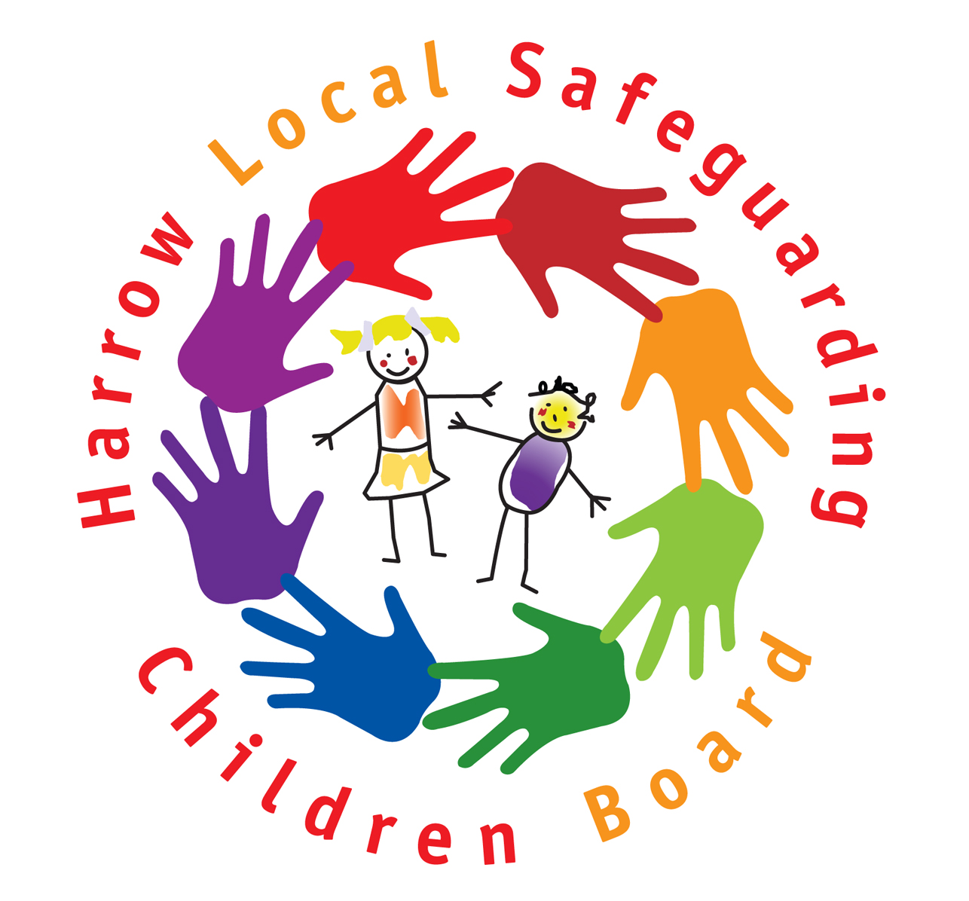

Title:
ALLEGATIONS OF ABUSE AGAINST STAFF AND VOLUNTEERS
(ROLES AND RESPONSIBILITIES)
Date Created:  January 2007 | Last Review Date:  February 2012 | Originator:  LADO’s:  Steve Spurr & Anna Tenconi
Version:  V.02 | Next Review Date:  February 2013 | Protective Marking:  None

ALLEGATIONS OF ABUSE AGAINST STAFF AND VOLUNTEERS
(ROLES AND RESPONSIBILITIES)
STRATEGIC  Named Senior Officer  LSCB member organisations (includes the Local Authority) should identify:  - a named senior officer with overall responsibility for:  - ensuring the organisation operates procedures in accordance with the guidance in Appendix 5 of Working Together 2010*  - resolving any inter-agency issues  - liaising with the Local Safeguarding Children Board (LSCB) on the subject  Senior Police Officer  Police forces should identify:  - a senior officer to:  - have strategic oversight of the arrangements for dealing with allegations against those who work with children  - liaise with the LSCB’s in the force area  - ensure compliance  OPERATIONAL  Designated Senior Manager  Employers and Voluntary Groups should:  - identify a senior manager/person within the organization to whom allegations or concerns that a member of staff or volunteer may have abused a child should be reported  - identify an alternative person to whom reports should be made in the absence of the named senior manager, or in cases where that person is the subject of the allegation or concern  - make sure that all staff and volunteers know who these persons are | Police Unit Managers  Police forces should identify unit managers to:  - liaise with the LADO(s)  - take part in strategy discussions  - review the progress of cases in which there is a police investigation  - share information on completion of the investigation or any prosecution  Local Authority Designated Officer (LADO)  Local Authorities should designate officer(s) to:  - be involved in the management and oversight of individual cases  - provide advice & guidance to employers and voluntary organisations  - liaise with the police & other agencies  - monitor the progress of cases to ensure that they are dealt with as quickly as possible consistent with a thorough and fair process  Procedures  The LSCB is responsible for:  - ensuring that there are effective inter-agency procedures in place  - monitoring and evaluating the effectiveness of those procedures  All organisations that provide services for children, or provide staff or volunteers to work with or care for children, should operate a procedure which:  - deals with handling allegations or concerns that a member of staff or volunteer may have abused a child  - is consistent with the guidance in Appendix 5 of Working Together  - identifies the senior manager to whom all allegations and concerns should be reported, and his/her deputy  - includes contact details for the LADO

* Working Together to Safeguard Children - A guide to inter-agency working to safeguard and promote the welfare of children HM Government 2010

